WQF7006 Explainable AI
Assignment 3 Report

Name: Muhammad Haziq Faiz Bin Mohd Ripin
ID 24218182
Date: January 2026

Table of Contents
Task 1: Data Preparation 4
1.1 Overview 4
1.2 Data Loading and Splitting 4
1.3 Handling Class Imbalance 4
1.4 Dataset Transformation 4
Task 2: Model Training & Comparison 6
2.1 Model 1: Custom CNN 6
2.2 Model 2: ResNet18 (Transfer Learning) 6
2.3 Model 3: EfficientNet-B0 (Transfer Learning) 6
2.4 Training Configuration 6
2.5 Performance Comparison and Results 7
Task 3 & 4: XAI Method 1: Grad-CAM 11
3.1 Grad-CAM Explanation for Custom CNN 11
3.2 Grad-CAM Explanation for ResNet18 13
3.3 Grad-CAM Explanation for EfficientNet-B0 15
Task 5 & 6: XAI Method 2: RISE 17
4.1 RISE Explanation for Custom CNN 17
4.2 RISE Explanation for ResNet18 19
4.3 RISE Explanation for EfficientNet-B0 21
Conclusion 23

Figure 1: Confusion Matrix of Custom CNN 7
Figure 2: Learning Curve of Custom CNN 7
Figure 3: Confusion Matrix of Resnet18 8
Figure 4: Training Curve of Resnet18 8
Figure 5: Confusion Matrix of EfficeintNet-B0 9
Figure 6: Training Curve of EfficientNet-B0 9
Figure 7: F1 Score Comparison of All Three Models 10
Figure 8: Grad-CAM Visualization of True Positive Custom CNN 11
Figure 9 Grad-CAM Visualization of False Positive Custom CNN 11
Figure 10: Grad-CAM Visualization of True Negative Custom CNN 12
Figure 11: Grad-CAM Visualization of False Negative Custom CNN 12
Figure 12: Grad-CAM Visualization of True Positive Resnet18 13
Figure 13: Grad-CAM Visualization of False Positive Resnet18 13
Figure 14: Grad-CAM Visualization of True Negative Resnet18 14
Figure 15: Grad-CAM Visualization of False Negative Resnet18 14
Figure 16: Grad-CAM Visualization of True Positive EfficientNet-B0 15
Figure 17: Grad-CAM Visualization of False Positive EfficientNet-B0 15
Figure 18: Grad-CAM Visualization of True Negative EfficientNet-B0 16
Figure 19: Grad-CAM Visualization of False Negative EfficientNet-B0 16
Figure 20: RISE Visualization of True Positive Custom CNN 17
Figure 21: RISE Visualization of False Positive Custom CNN 17
Figure 22: RISE Visualization of True Negative Custom CNN 18
Figure 23: RISE Visualization of False Negative Custom CNN 18
Figure 24: RISE Visualization of True Positive Resnet18 19
Figure 25: RISE Visualization of False Positive Resnet18 19
Figure 26: RISE Visualization of True Negative Resnet18 20
Figure 27: RISE Visualization of False Negative Resnet18 20
Figure 28: RISE Visualization of True Positive EfficientNet-B0 21
Figure 29: RISE Visualization of False Positive EfficientNet-B0 21
Figure 30: RISE Visualization of True Negative EfficientNet-B0 22
Figure 31: RISE Visualization of False Negative EfficientNet-B0 22

Task 1: Data Preparation

1.1 Overview
The dataset consists of chest X-ray images categorized into two classes: NORMAL and PNEUMONIA. The objective was to prepare this data for a Deep Learning model while ensuring the training process is not biased toward the majority class (Pneumonia).

1.2 Data Loading and Splitting
Using the torchvision.datasets.ImageFolder class, the data was organized into three distinct sets. The input features consist of the image pixel data, while the target features are the class indices (0 for Normal, 1 for Pneumonia).
Dataset Distribution:
- Training - 5,683
- Validation - 2,270
- Test - 2,251

1.3 Handling Class Imbalance
An analysis of the dataset revealed a class imbalance, where "PNEUMONIA" samples significantly outnumber "NORMAL" samples. To prevent the model from becoming biased toward the majority class, a WeightedRandomSampler was implemented.
The "NORMAL" images are oversampled, ensuring that each batch seen by the model is balanced. This is crucial for achieving a high F1 Score, as it prevents the model from simply predicting the majority class to achieve high accuracy.

1.4 Dataset Transformation
To ensure the model receives consistent data and to improve its ability to generalize to unseen X-rays, a transformation pipeline was implemented using torchvision.transforms.
- Resizing: All images were resized to 224x224 pixels to match standard deep learning architecture requirements.
- Geometric Augmentation: Applied Random Horizontal Flips (50% chance) and Random Rotations (up to 10°) to simulate variations in patient positioning.
- Photometric Augmentation: Used Color Jitter to vary brightness and contrast by 20%, helping the model handle different X-ray exposure levels.
- ToTensor(): Converted image pixel intensities from the range [0, 255] to floating-point tensors in the range [0.0, 1.0].
- Normalization: Applied the standard ImageNet statistics:
  - Mean: [0.485, 0.456, 0.406]
  - Std: [0.229, 0.224, 0.225]$

Task 2: Model Training & Comparison
Three distinct models were developed and compared to determine the best performing architecture for Pneumonia detection.

2.1 Model 1: Custom CNN
A "from-scratch" architecture designed specifically for this task.
Structure: Consists of 4 Convolutional blocks. Each block utilizes Batch Normalization to stabilize learning and MaxPooling to reduce spatial dimensions.
Optimization: Instead of a massive fully connected layer, it uses Global Average Pooling (GAP) before the final classifier to reduce the total number of parameters and minimize overfitting.
Regularization: Dropout layers (0.5 and 0.3) were added to improve generalization.

2.2 Model 2: ResNet18 (Transfer Learning)
A state-of-the-art residual network pre-trained on ImageNet.
Mechanism: Residual connections (skip-connections) allow for training deeper networks by mitigating the vanishing gradient problem.
Fine-tuning Strategy: Early layers were frozen to retain general feature extraction capabilities (edges/textures). The final residual block (layer 4) and the fully connected head were unfrozen to adapt specifically to medical X-ray features.

2.3 Model 3: EfficientNet-B0 (Transfer Learning)
An architecture known for its efficiency, optimized using a "compound scaling" method that balances depth, width, and resolution.
Fine-tuning Strategy: Similar to ResNet18, only the final feature blocks and the classifier head were trained. This model is computationally lighter while maintaining high accuracy.

2.4 Training Configuration
To ensure a fair comparison, all models were trained under the following identical conditions:
Epochs: 7
Learning Rate: 0.001
Loss Function: Weighted CrossEntropyLoss.

2.5 Performance Comparison and Results
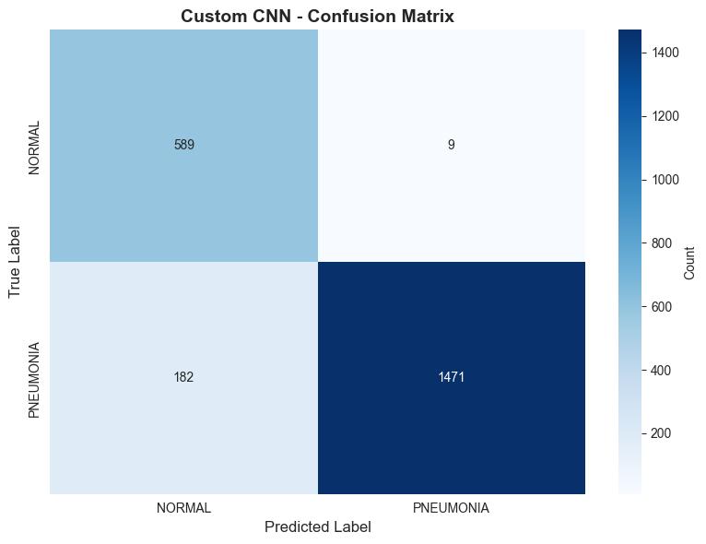
Figure 1: Confusion Matrix of Custom CNN
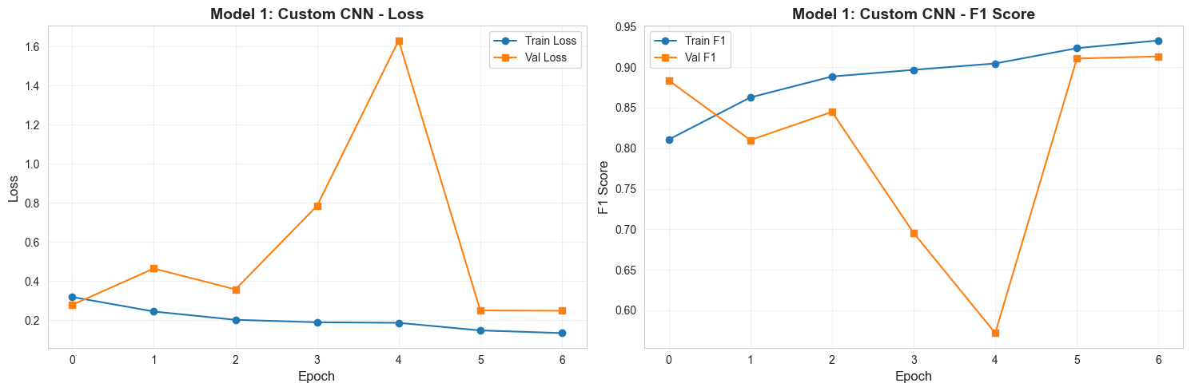
Figure 2: Learning Curve of Custom CNN

The custom CNN struggled with false negative, and it have a sharp drop of F1 score during the 4th epoch.

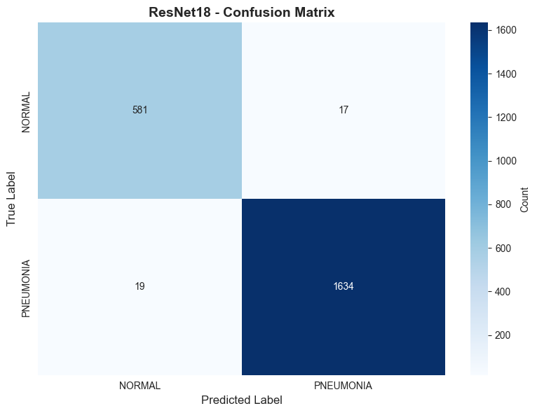
Figure 3: Confusion Matrix of Resnet18
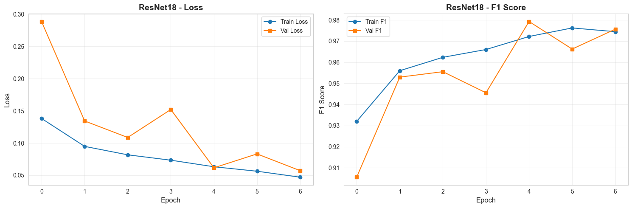
Figure 4: Training Curve of Resnet18
Resnet18 model produced a very low number of false positives and false negatives, and it shows no sign of overfitting.

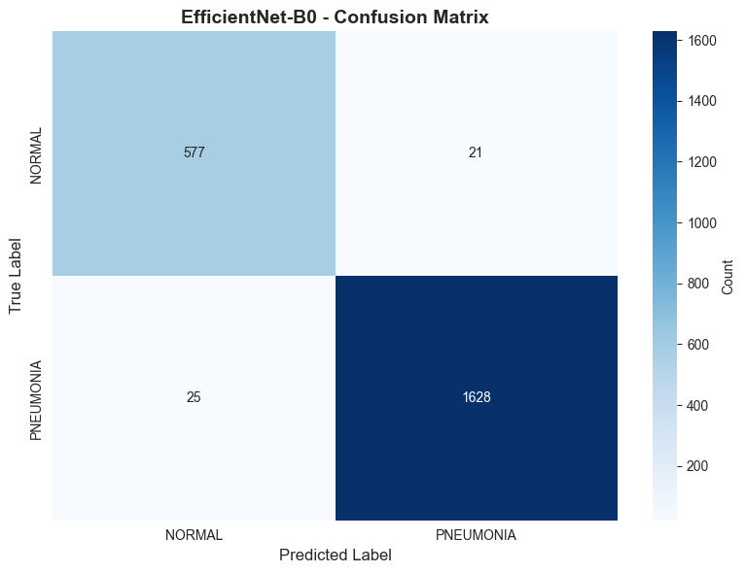
Figure 5: Confusion Matrix of EfficeintNet-B0
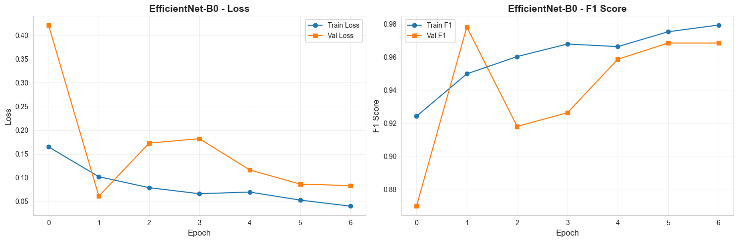
Figure 6: Training Curve of EfficientNet-B0

The EfficientNet-B0 has a slightly higher number of false positives and false negatives compared to Resnet18. It also shows a little sign of overfitting.

Model type | Architecture Summary | F1 Score
Model 1: Custom CNN | 4 Conv Blocks (BatchNorm + MaxPooling) with Global Average Pooling | 0.939036
Model 2: ResNet18 | Pre-trained Residual Network (Transfer Learning - Layer 4 fine-tuned) | 0.989104
Model 3: EfficientNet-B0 | Pre-trained EfficientNet (Transfer Learning - Classifier fine-tuned) | 0.986069
Table 1: Summary of Model Performance

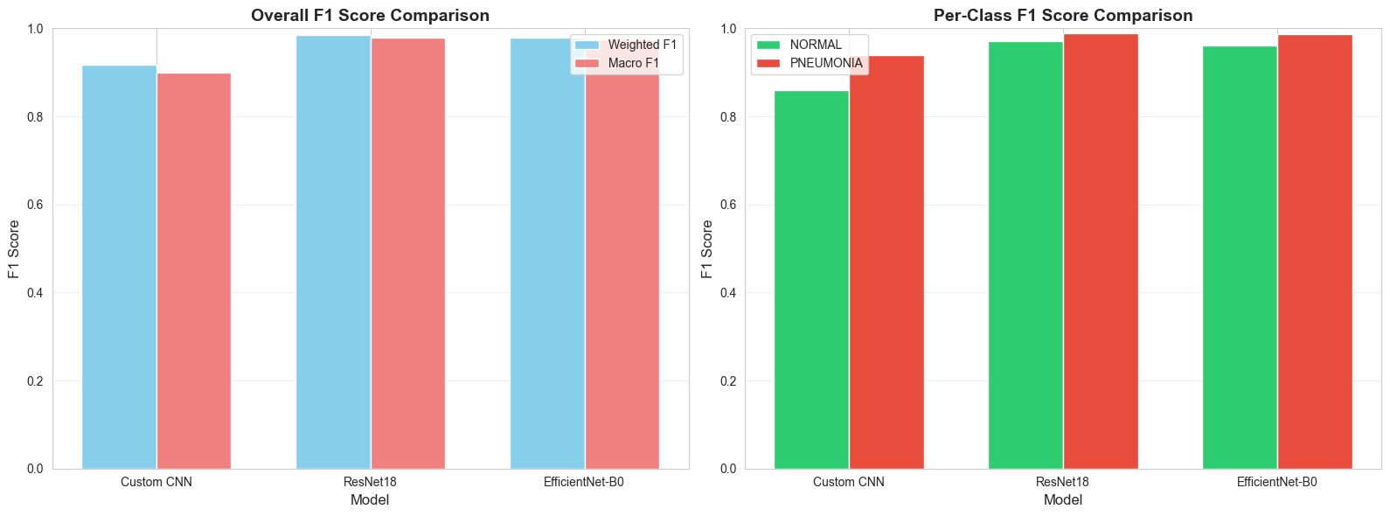
Figure 7: F1 Score Comparison of All Three Models
Table 1 summarize the performance of all 3 models. ResNet18 has the highest DF1 score followed by EfficientNet-B0 and the custom CNN is in last place.

Task 3 & 4: XAI Method 1: Grad-CAM

3.1 Grad-CAM Explanation for Custom CNN
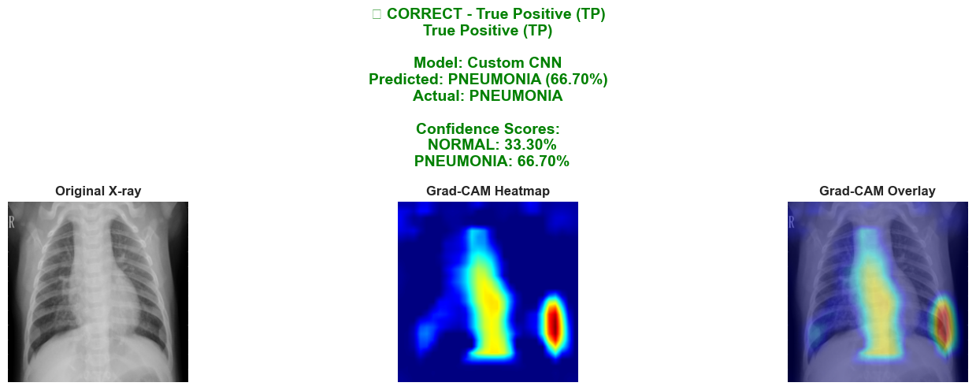
Figure 8: Grad-CAM Visualization of True Positive Custom CNN
In Figure 8, while the prediction is correct, the heatmap shows that the model is not looking at the entire lung field equally. It is primarily focused on the central structures and one specific peripheral point, rather than the lower lung bases where pneumonia often presents.
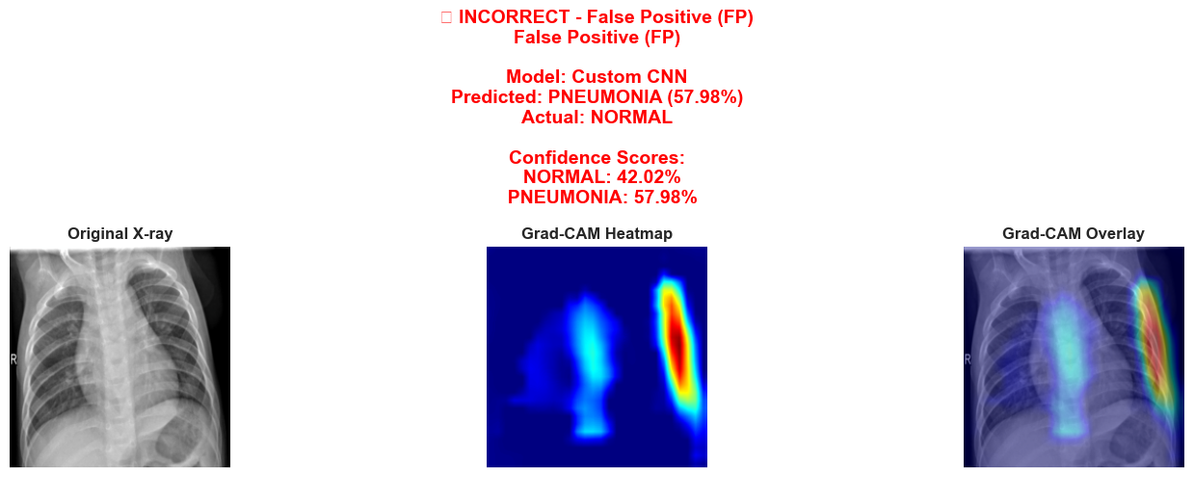
Figure 9 Grad-CAM Visualization of False Positive Custom CNN
In Figure 9, the prediction is wrong as the model focused on the left side of the chest. In a lot of false positive cases we encountered the model would randomly focus on the left side of the chest.
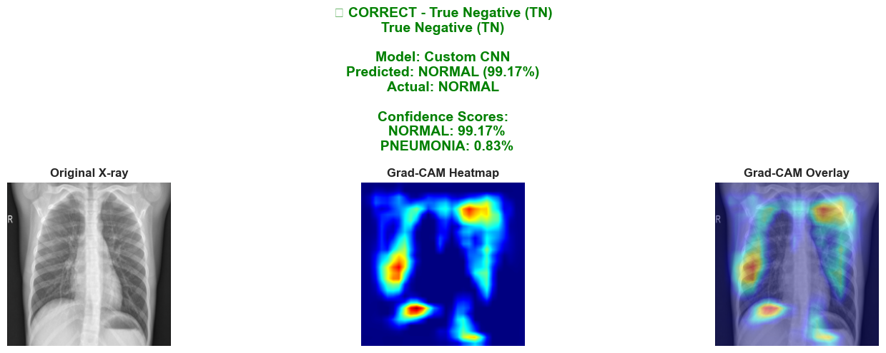
Figure 10: Grad-CAM Visualization of True Negative Custom CNN
Unlike the focal, high intensity blobs typically seen in pneumonia cases, the activation here is more dispersed across the lung fields. This is a good sign, as it indicates the model found no single concentrated area of concern.
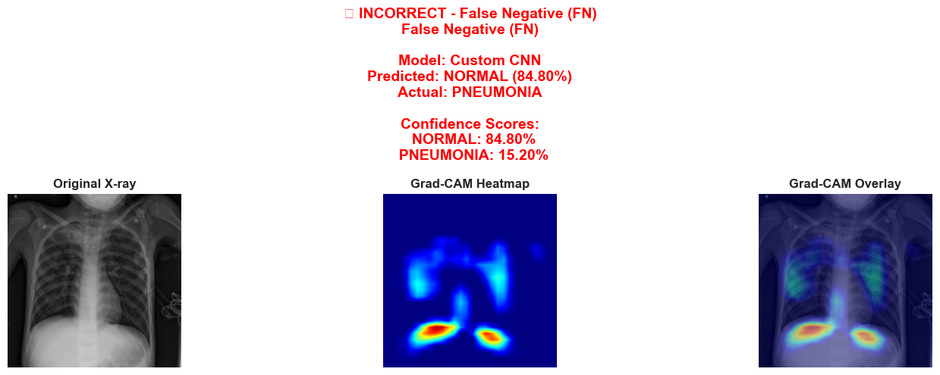
Figure 11: Grad-CAM Visualization of False Negative Custom CNN

The model failed to have a high intensity heat map near the center of the lung which resulted in a false negative.

3.2 Grad-CAM Explanation for ResNet18
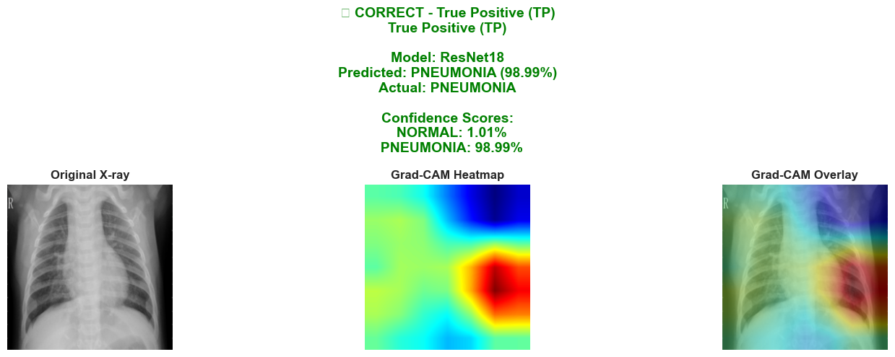
Figure 12: Grad-CAM Visualization of True Positive Resnet18
Even though ReseNet18 has the highest F1 score, a lot of the true positive cases show a high intensity heatmap at the left side of the chest as shown in Figure 12.
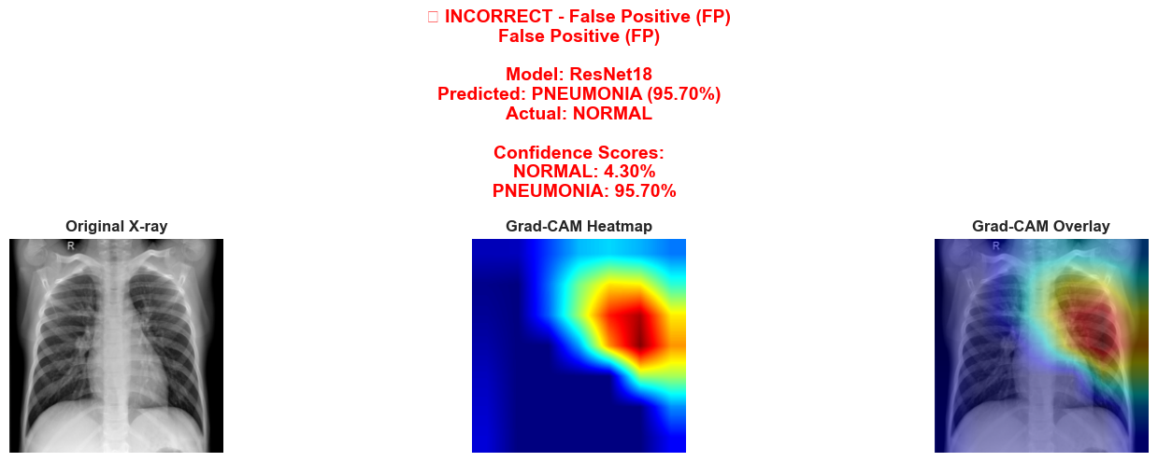
Figure 13: Grad-CAM Visualization of False Positive Resnet18
In Figure 13, because the model produced a high intensity heat map on the left side of the chest, it classified this as a false positive.
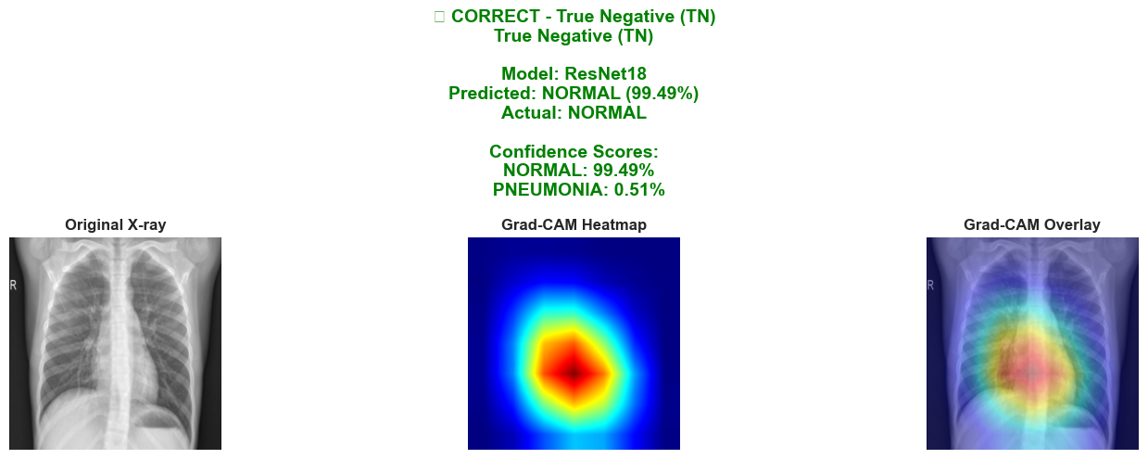
Figure 14: Grad-CAM Visualization of True Negative Resnet18
Interestingly, Resnet18 would produce a high intensity heatmap around the center of the chest for normal lungs as shown in Figure 14.
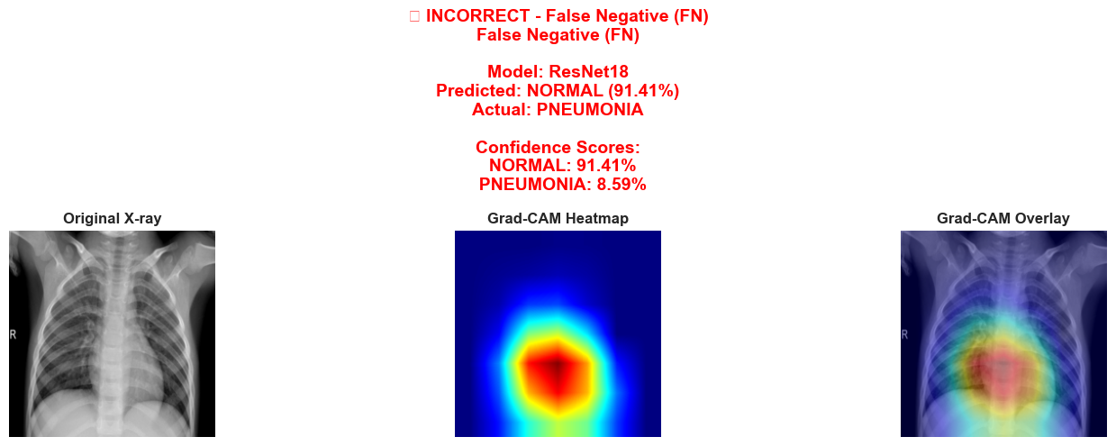
Figure 15: Grad-CAM Visualization of False Negative Resnet18
In Figure 15, because the model produced a high intensity heat map on center of the chest, thus resulting in a false negative.

3.3 Grad-CAM Explanation for EfficientNet-B0
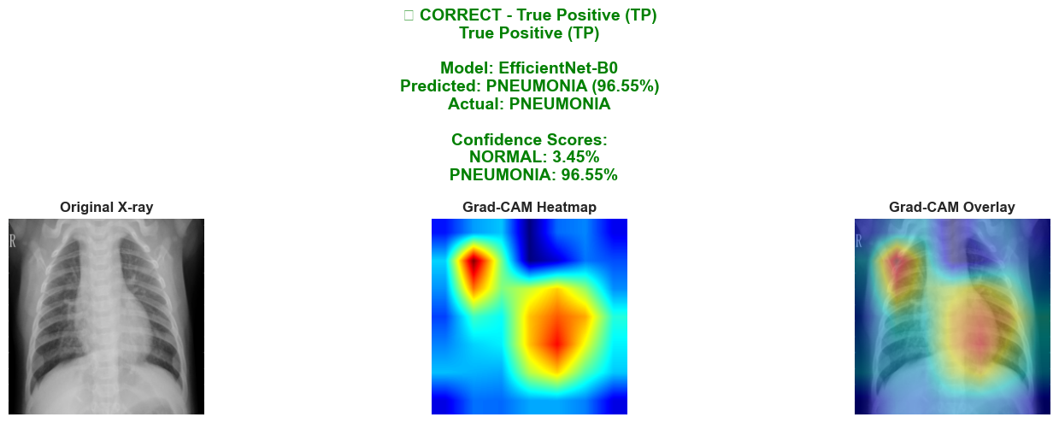
Figure 16: Grad-CAM Visualization of True Positive EfficientNet-B0
The model produced a high intensity heat ap around the center of the chest as shown in Figure 16.
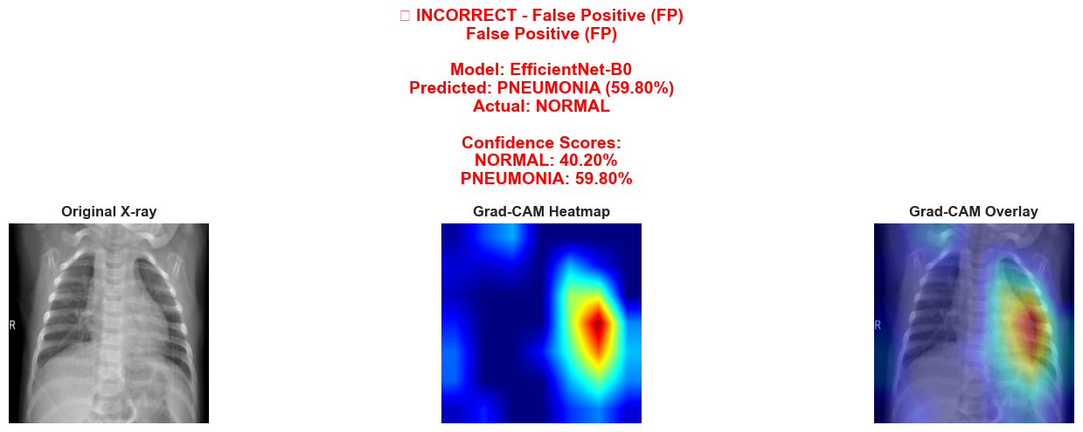
Figure 17: Grad-CAM Visualization of False Positive EfficientNet-B0
In Figure 17, false positive happens as the model produced a high intensity heat ma on the left side of the chest.
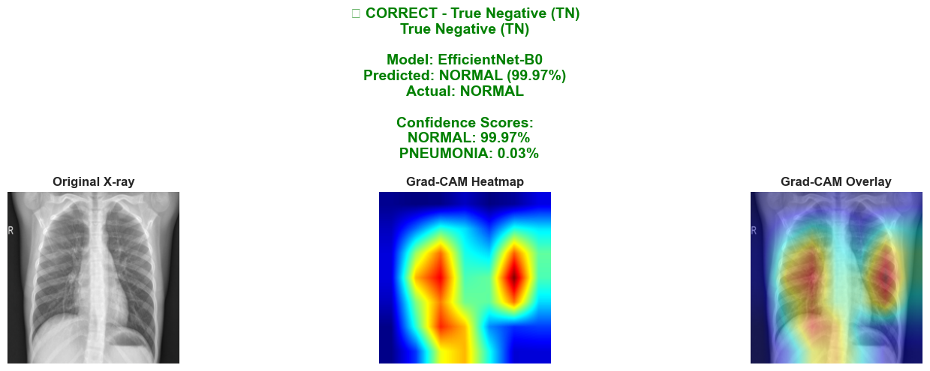
Figure 18: Grad-CAM Visualization of True Negative EfficientNet-B0
We found out that the model would classify an image as ‘NORMAL’ if there is activity on the right side of the chest as shown in Figure 18.

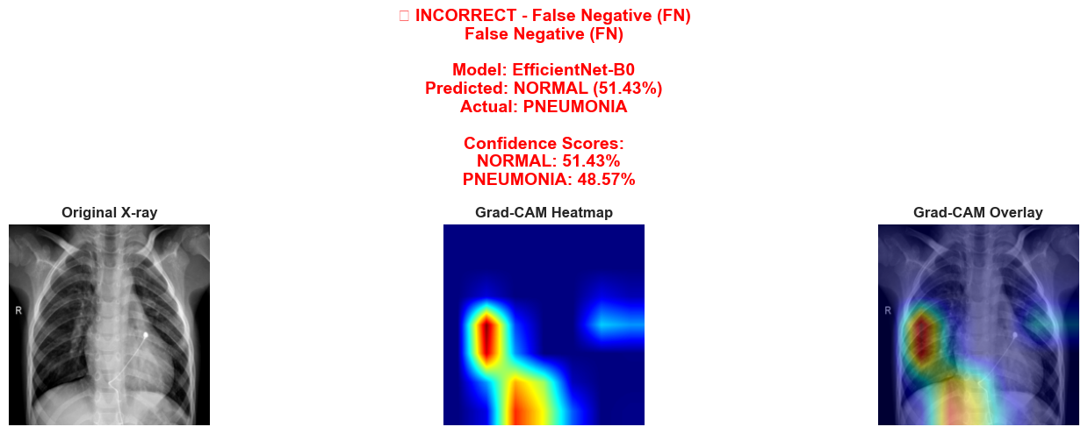
Figure 19: Grad-CAM Visualization of False Negative EfficientNet-B0
In Figure 19 false negative happened as there is a high interest in the right side of the chest.

Task 5 & 6: XAI Method 2: RISE

4.1 RISE Explanation for Custom CNN
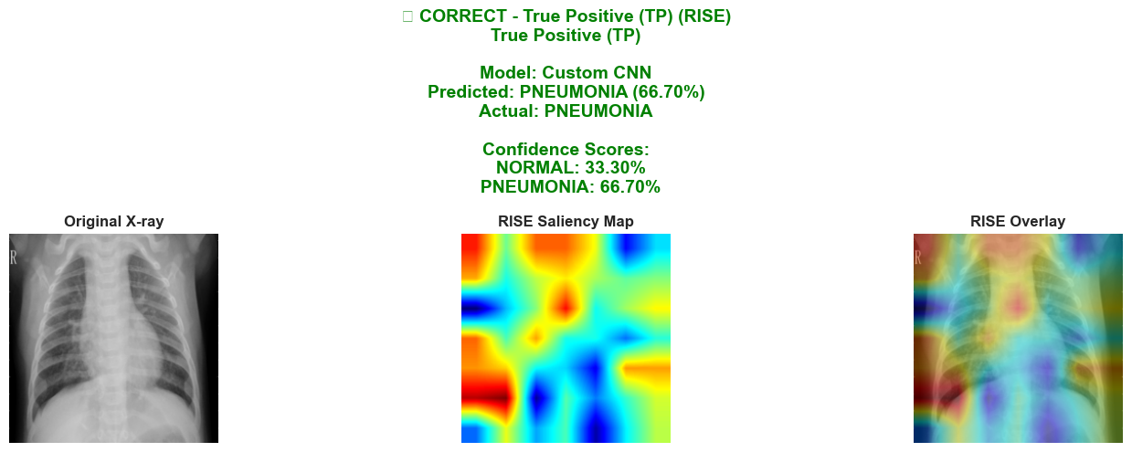
Figure 20: RISE Visualization of True Positive Custom CNN
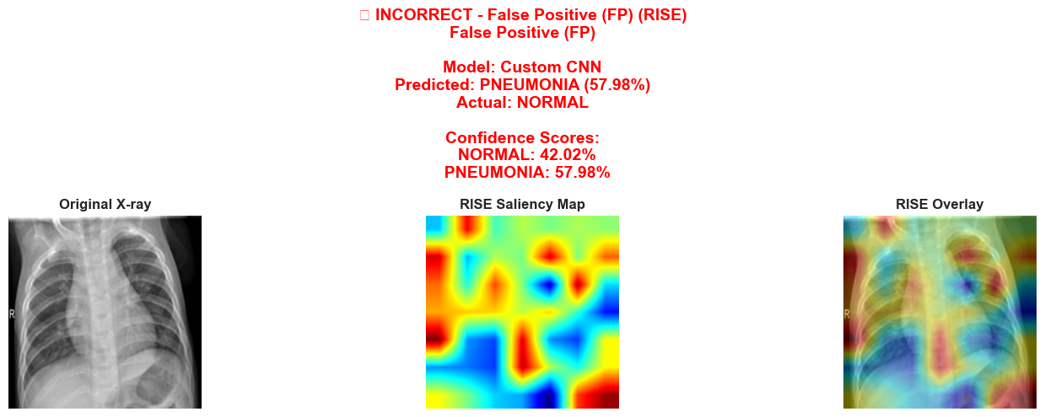
Figure 21: RISE Visualization of False Positive Custom CNN
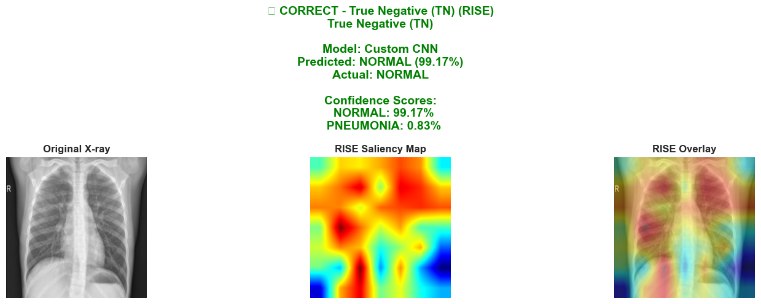
Figure 22: RISE Visualization of True Negative Custom CNN
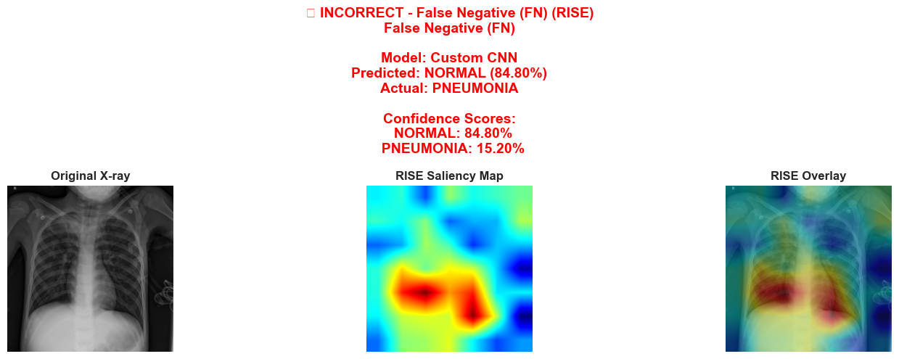
Figure 23: RISE Visualization of False Negative Custom CNN

As shown in Figure 20,21,22 and 23, RISE heatmap looks much more scattered and noisier compared to the smooth blobs produced by Grad-CAM. Unlike Grad-CAM, which looks at the internal "logic" of the neural network (gradients), RISE is a perturbation-based method. It works by throwing thousands of random masks over your image and seeing how the prediction score changes. This suggests that the model isn't just looking at the lung to detect pneumonia. It has learned that certain background textures are correlated with pneumonia. Compared to Grad-CAM, the RISE map shows that the model is giving quite a lot of importance to areas that have nothing to do with the actual diagnosis.

4.2 RISE Explanation for ResNet18
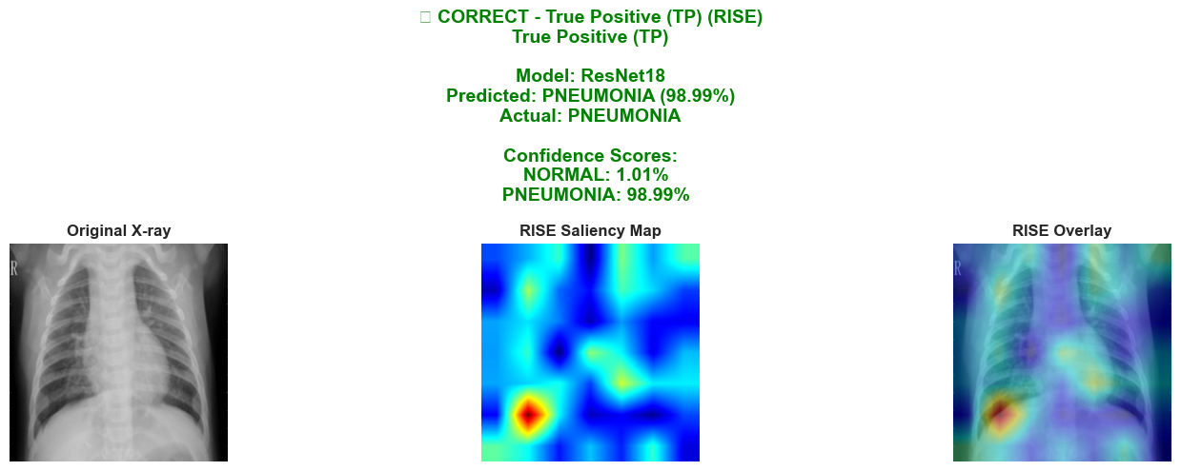
Figure 24: RISE Visualization of True Positive Resnet18
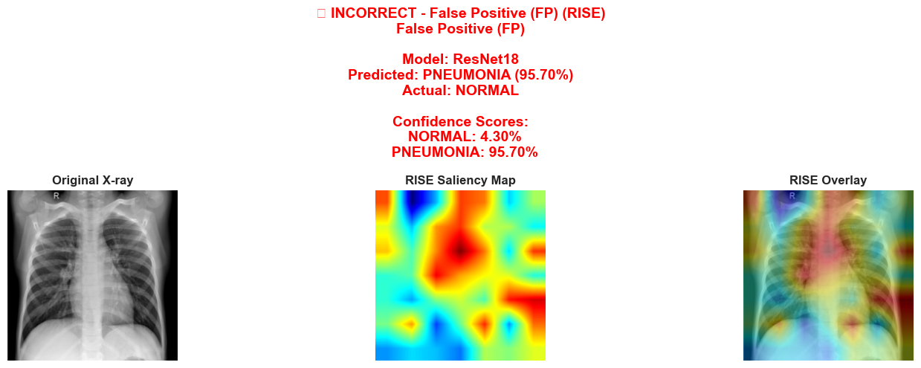
Figure 25: RISE Visualization of False Positive Resnet18
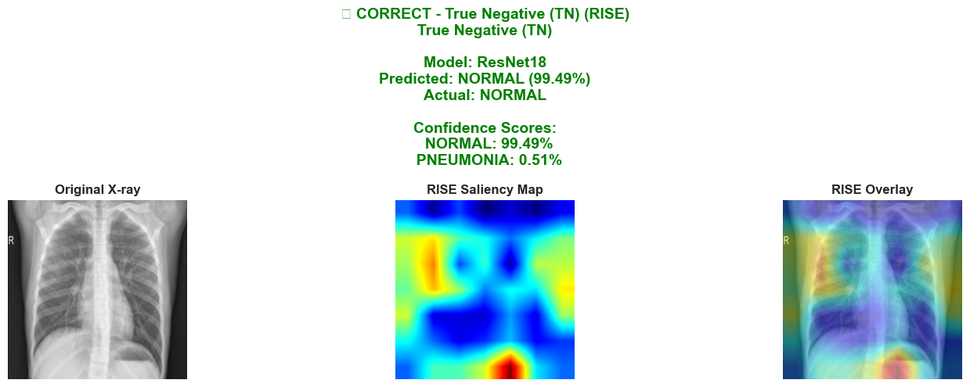
Figure 26: RISE Visualization of True Negative Resnet18
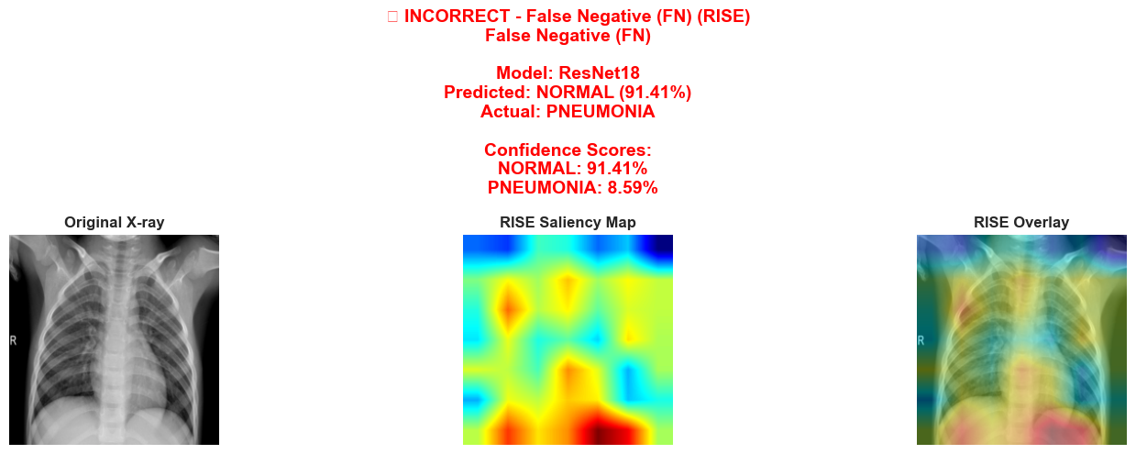
Figure 27: RISE Visualization of False Negative Resnet18

The same noisy RISE heatmaps are produced by Resnet18 and it have the same explanation as the RISE heatmaps from custom CNN.

4.3 RISE Explanation for EfficientNet-B0
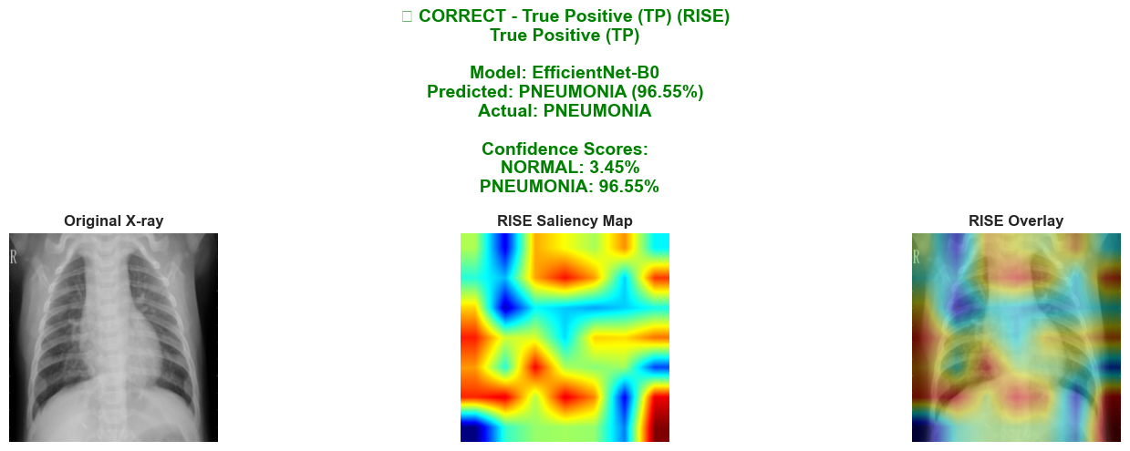
Figure 28: RISE Visualization of True Positive EfficientNet-B0
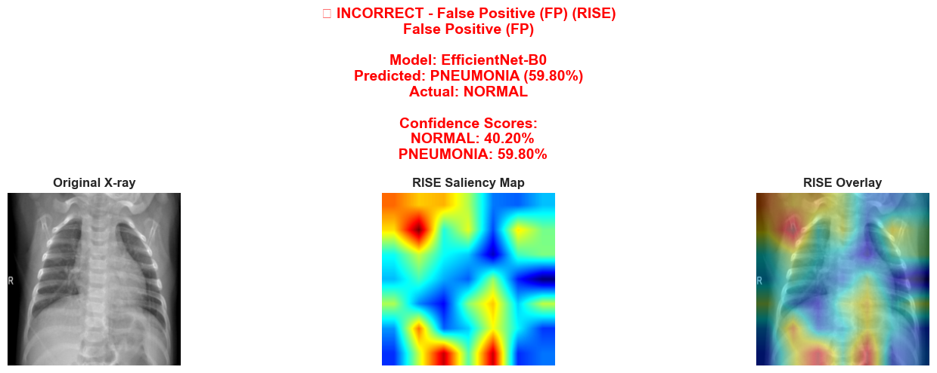
Figure 29: RISE Visualization of False Positive EfficientNet-B0
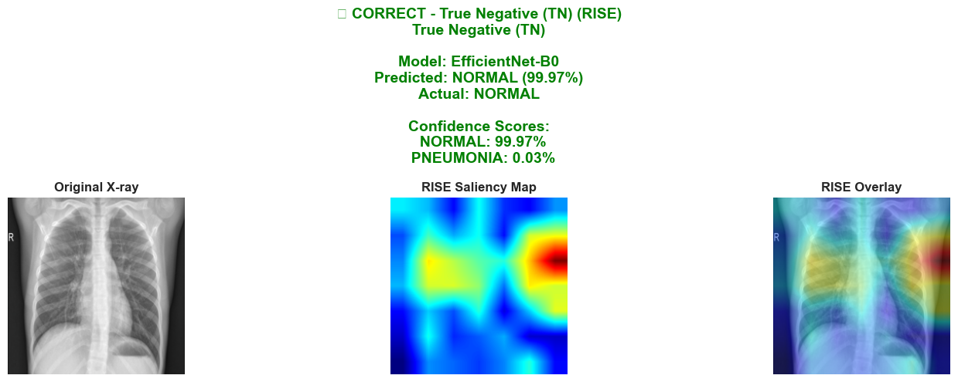
Figure 30: RISE Visualization of True Negative EfficientNet-B0
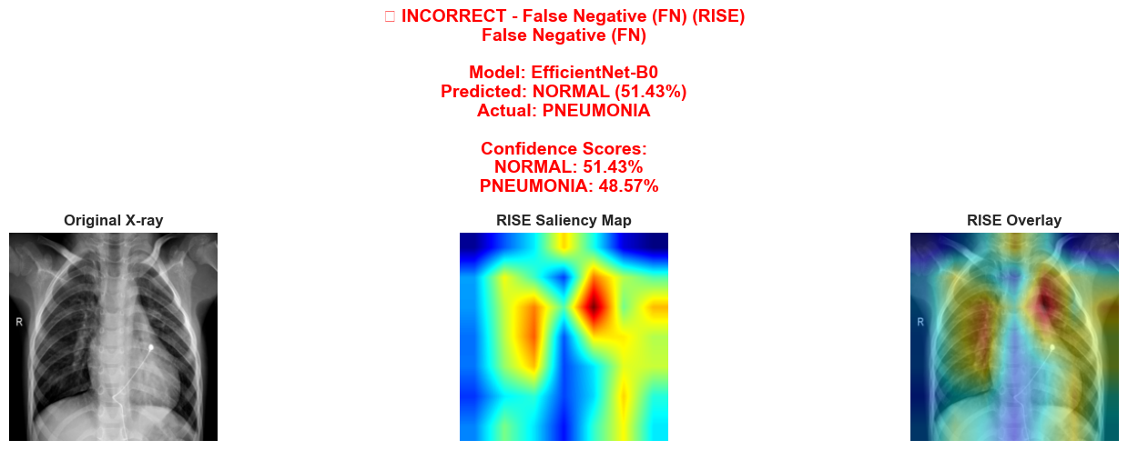
Figure 31: RISE Visualization of False Negative EfficientNet-B0

As seen in Figure 28 and 19, EfficientNet-B0 would predict the image as ‘Pneumonia’ if the heatmap is all over the place. It will classify as ‘Normal’ if there are only one or two high intensity region.

Conclusion
Among the three architectures evaluated, ResNet18 achieved the highest F1 score. This suggests that its residual connections and depth provide the best balance for extracting complex features from chest X-ray imagery compared to the other model.
Grad-CAM successfully highlights clinically interesting regions. It produced smooth, intuitive heatmaps that generally aligned with human anatomical expectations, making the model's decisions appear logically grounded in thoracic pathology.
Despite the high F1 scores, the RISE analysis provided a critical reality check. RISE revealed that all three models frequently focused on non-anatomical shortcuts (such as image borders, neck tissue, or radiographic noise). This indicates that the models' high accuracy is partially driven by correlations in the dataset rather than a true understanding of pneumonia indicators.

